**Confidence interval for Mean of n(µ,σ2) population**

Case-I : When population varience (σ2) is known

Required confidence interval is

P(x’-Zα/2 √(σ2 /n) ≤ µ ≤ x’+Zα/2√(σ2 /n)) = 1 – α

where,

µ = population mean

n = sample size

x’ = sample mean

σ2 = population varience

1 – α = confidence level

α = level of significance

Case-II : When population variance(σ2) is unknown

Subcase(a): when sample is large(n > 30)

In this case use

(x’ – µ)/(s/√n)

where,

s = √((1/n)∑x2 – x’2)

so required confidence interval is,

P(x’-Zα/2 * (s/√n) ≤ µ ≤ x’+ Zα/2 * (s/√n)) = 1 – α

Subcase(b): when sample is small (n < 30)

It will be discussed after following two distributions:

I) kai-square distribution

II) t-distribution

In this case we use,

(x’-µ)/√(S2/n) ~ tn-1

Now confidence interval is,

P(-tα/2,n-1 ≤ (x’-µ)/√(S2/n) ≤ tα/2,n-1 ) = 1 – α

rearranging,

P(x’-tα/2 √(S2 /n) ≤ µ ≤ x’+tα/2√(S2 /n)) = 1 – α

**ϗ2 Distribution:**

n∑i=1 iZ2 ~ nϗ2 → kai-square distribution with n-degree of freedom.

The probability that

nϗ2 distribution exceeds a particular value ‘c’ is ,

P(nϗ2 ≥ c) = c∫∞ (1/2(n/2)*√(n/2))*e(-1/2) nϗ2 nϗ2(n/2)-1 d nϗ2

**Notes:**

1) width of C.I = 2* Zα/2 *√(σ2 /n)

2) standard error of sample mean, s.e(x’) = V(x’) = √(σ2 /n) = σ / √n

3) error in estimation of µ :

If µ is opoulation mean and x’ is sample mean obtained from the sample of size n, Then:

Error = |x’ – µ|

Since µ is unknown, another alternative is,

Error ≤ Zα/2 \***(**σ/√n)

Next the maximum error is,

Emax = Zα/2 \***(**σ/√n)

Sample size for estimating µ:

n = ((Zα/2*σ)/Emax )2

Problem:

1.What is the value of maximum error that may be committed in

estimating population mean with a sample of size 24 with 95% confidence level, if population variance is known to be 2.4.

→ here,

sample size(n) = 24

confidence level (1-α) = 0.95 so α = 0.05

population variance(σ2) = 2.4

now,

Emax = Zα/2 \***(**σ/√n)

= 1.96 * (√2.4/√24)

= 1.96 * √0.1

= 0.619

How many sample observations are required to estimate population mean at 95% confidence level. If max tolerence in error is 0.3 with population SD known to be 1.6.

→ here,

Emax = 0.3

1 – α = 0.95 or α = 0.05

σ = 1.6

now,

n = ((Zα/2*σ)/Emax )2

= ((1.96 * 1.6)/ 0.3)2P

= 109.27 ≈ 110

3. The average zinc concentration received form a sample of measurement in 35 different locations is found to be 2.6 gm/mm with SD of 0.43. Construct 90% confidence interval for actual mean zinc concentration .

→ Let µ denote actual mean concentration.

Here poulation variance is not given and sample is large(n>30)

so, required confidence interval is,

P(x’-Zα/2 * (s/√n) ≤ µ ≤ x’+ Zα/2 * (s/√n)) = 1 – α

P(2.6 – Zα/2 * (0.3/√35) ≤ µ ≤ 2.6 + Zα/2 * (0.3/√35)) = 0.90

P(2.6 – 0.507* (0.3/√35) ≤ µ ≤ 2.6 + 0.507* (0.3/√35)) = 0.90

P(2.6 – 0.83 ≤ µ ≤ 2.6 + 0.83) = 0.90

P(1.77 ≤ µ ≤ 3.43) = 0.90

4. The life time of 10 ICs is observed to have mean of 4.5 years. If it is known that the life time time of ICs is normally distributed with varince of 2.5 , then construct 95% confidence interval for actual average life time of ICs.

→ Soln ,

let “X” be rv denoting lifr time of ICs. Given,  
X~N(µ , σ2), where σ2 = 2.5

Since popn varience is given so, required confidence interval is,

P(x’-Zα/2 √(σ2 /n) ≤ µ ≤ x’+Zα/2√(σ2 /n)) = 1 – α

here,

sample mean(x’) = 4.5 , Sample size(n) = 10

confidence interval(1 – α) = 0.95 so, α = 0.05

→ P(4.5 – Z0.05/2√(2.5/10) ≤ µ ≤ 4.5 + Z0.05/2√(2.5/10)) = 1 – α

or, P(4.5 – 1.96*0.5 ≤ µ ≤ 4.5 + 1.96*0.5 ) = 0.95

or, P(3.52 ≤ µ ≤ 5.46) = 0.95

5. 20 measurements on residual flaming time (in seconds) of treated specimens of children’s dress are presented below,

9.85 , 9.93, 9.75 ,9.77, 9.67, 9.87, 9.67, 9.84, 9.85, 9.75, 9.83, 9.92, 9.74, 9.99, 9.88, 9.95, 9.95, 9.93, 9.92, 9.89

Construct 95% confidence interval for mean residual flaming time.

→ Soln,

let µ denote actual mean flaming time.

Here popn varience is not given and sample is small. So required confidence interval is,

P(x’-tα/2 √(S2 /n) ≤ µ ≤ x’+tα/2√(S2 /n)) = 1 – α

working table;

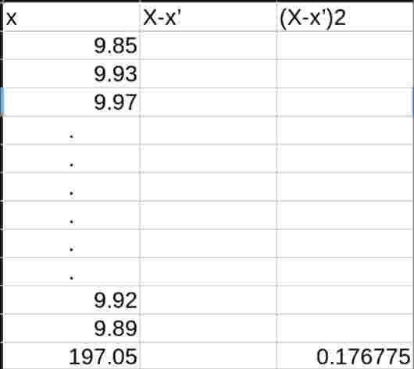

here,

x’ = 1/n∑x = 1/20*197.05 = 9.8525

S2  = 0.009304

hence,

P(9.8525-t0.05/2,20-1 √(0.0009304/20) ≤ µ ≤ 9.8525+t0.05/2,20-1 √(0.0009304/20)) = 1 – 0.05

P(9.8525-2.093 * 0.216 ≤ µ ≤ 9.8525+2.093 * 0.216 )= 0.95

P( 9.8074≤ µ ≤ 9.8976) = 0.95